# Undertaking by Parents

I hereby confirm that my ward Ms. Veda Samhitha bearing the student ID 22WU0101067 of B.Tech CSE (A) program registered for the A. Y 2022-2026

**Letter of Consent:**

I, father of the Veda Samhitha, 2022-2026 , B.Tech CSE (A), request you to permit **my daughter** to leave the campus **on 10/10/2025 at 6:00PM** for the purpose of holidays. My **daughter** shall return on the 12**/10/2025 at 8:00 PM**

Outing & leave are permitted only during university leave declared for festivals, national holidays, and weekends.

# The Parents/Guardian confirms the following,

1. I assure you that it is my responsibility for my ward during the outgoings and have been informed of the same by the university officials.
2. I firmly insist my ward not to deviate from the campus policy and adhere to the rules and regulations meticulously.

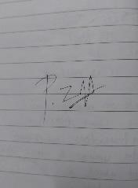

**Date: 09/10/2025 Parents Signature**

|  |  |  |  |
| --- | --- | --- | --- |
| Father Name, Email & Mobile Number | P. Jayaramulu | Jayaram.peddireddy@gmail.com | 9550717207 |
| Mather Name, Email & Mobile Number | Sailaja | - | 9491632655 |
| Student Name, Email & Mobile Number | Veda Samhitha | Samhitha.chowdary_2026@woxsen.edu.in | 8309094140 |